ArT
Pre-Trade Controls Engine
User Manual
FINRA Rule 4210 · Regulation T · 2026 Amendments

Table of Contents
1. Purpose of the ArT Platform 3
2. Platform Views 3
3. ArT Decision Outcomes 3
4. Regulatory Coverage 4
5. Navigating the Platform 5
5.1 Trade Generator (Stub 1) 5
5.2 Supervisory Approvals (Stub 2) 8
5.3 Rules Manager (Controls Team) 9
5.4 MI Dashboard (Management) 10
5.5 Audit Log (Compliance) 11

1. Purpose of the ArT Platform
ArT is a real-time pre-trade compliance decision engine designed to enforce regulatory requirements across equity and fixed-income trading desks. It intercepts every trade before execution and returns an immediate compliance decision with full reasoning, enabling traders, supervisors, and the controls team to act on accurate, auditable information.

2. Platform Views
The platform is organised into six views, each serving a distinct role in the pre-trade compliance workflow:
View | Role
Trade Generator | Stub to generate trades, single or in batch
Trader Entry | For Trader to manually submit a trade
Approvals | For Supervisor to override Hard Blocks
Rules Manager | For Controls Team to configure FINRA or Reg T or in-house custom rules
MI Dashboard | For Management reporting on blocks
Audit Log | For Compliance to check actions taken on the platform

3. ArT Decision Outcomes
Every trade submitted to ArT resolves to one of four outcomes:
Outcome | Meaning
Clean Pass | No rules triggered. Trade proceeds.
Soft Block | Warning issued. Trader acknowledges and can proceed.
Hard Block | Trade rejected. Regulatory hard limit — no override path.
Hard Block with Override | Trade blocked pending supervisory approval.

4. Regulatory Coverage

Regulation T (12 CFR Part 220)
- 50% initial margin for equity purchases
- 150% collateral for short sales
- Full payment for cash accounts
- Fixed income margin by credit grade

FINRA Rule 4210 (2026 Amendments)
- Intraday Margin Level (IML) computation
- Intraday margin deficit framework
- Safe harbour thresholds
- 90-day freeze enforcement
- Portfolio margin sub-$5M check
- Pattern Day Trader (PDT) regime eliminated

5. Navigating the Platform
All views are reached from the fixed navigation menu on the left-hand side of the screen: Trade Generator, Trader, Approvals, Rules Manager, MI Dashboard, and Audit Log. Click any item to switch views — the active view is highlighted in blue. The sections below walk through each view in turn.

5.1 Trade Generator (Stub 1)
The Trade Generator is a testing stub that randomly generates trades and fires them at the ArT rules engine, covering all four outcome types across Equities and Fixed Income.
How to get here: Left-hand navigation menu → “Trade Generator” (top item, marked “Stub 1”).
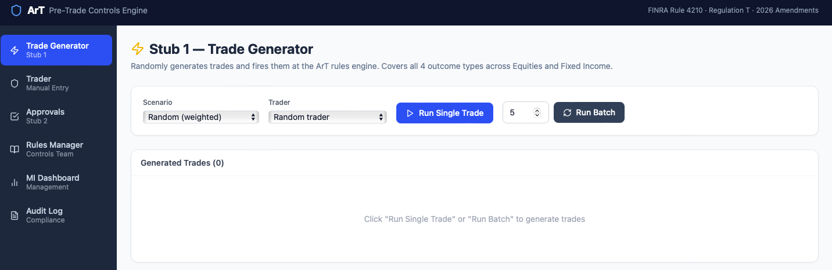
Figure 1 — Trade Generator default view, before any trades are run.
Use the Scenario dropdown to pick a specific outcome type to test (e.g. Clean Equity Buy, Hard Block Reg T, Frozen Account Short), or leave it on “Random (weighted)”.
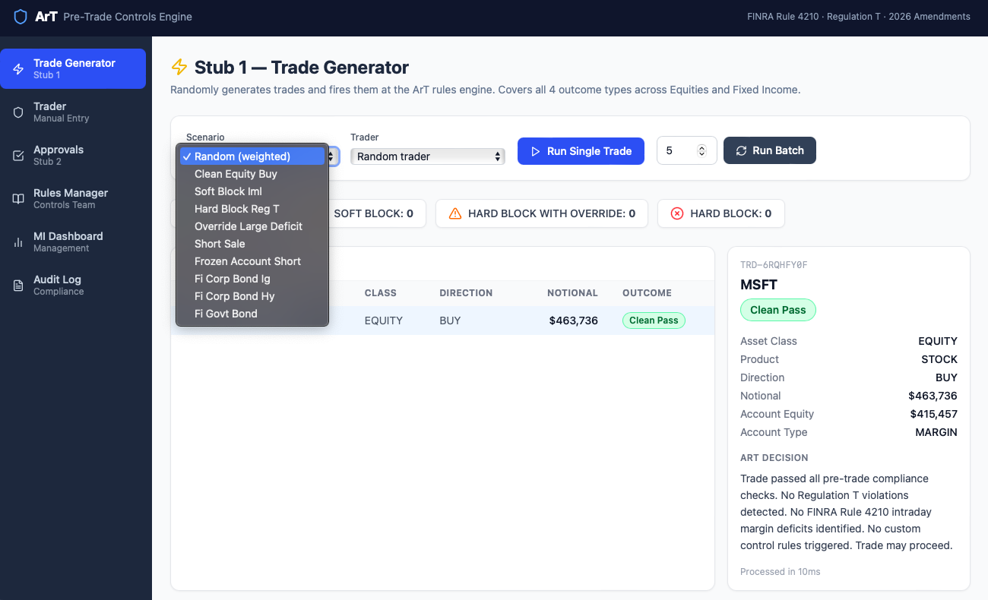
Figure 2 — Selecting a scenario from the dropdown.
Use the Trader dropdown to run the trade as a specific trader, or leave it on “Random trader”. Click “Run Single Trade” to generate one trade; the result and its full ArT Decision reasoning appear on the right.
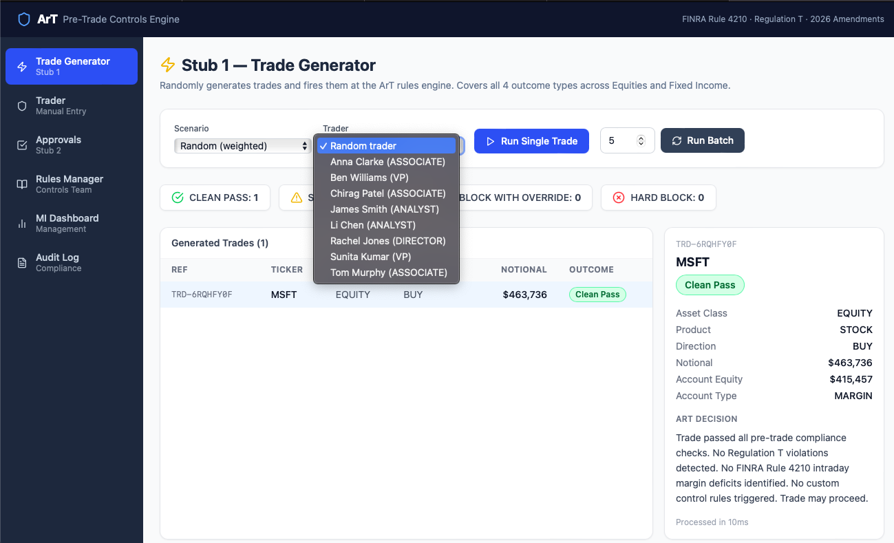
Figure 3 — Selecting a trader, and a single generated trade with its ArT decision detail on the right.
When a trade is blocked, the decision panel on the right lists every rule that is fired, with its rule code and a plain-language reason. Click any row in the trade list to inspect its decision.
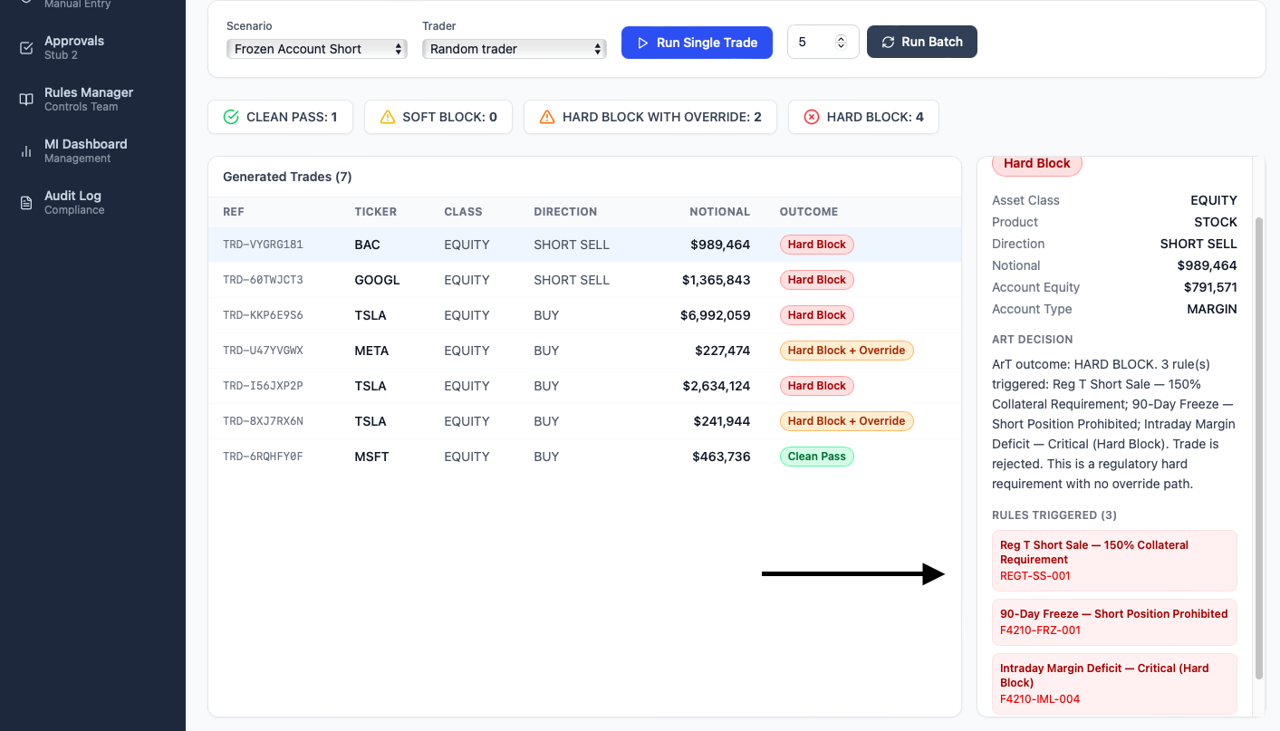
Figure 4 — A Hard Block outcome, showing the three rules triggered and the reasoning behind the rejection.
Set the batch size field and click “Run Batch” to generate multiple trades at once. The outcome counters at the top (Clean Pass, Soft Block, Hard Block with Override, Hard Block) update live as trades are generated.
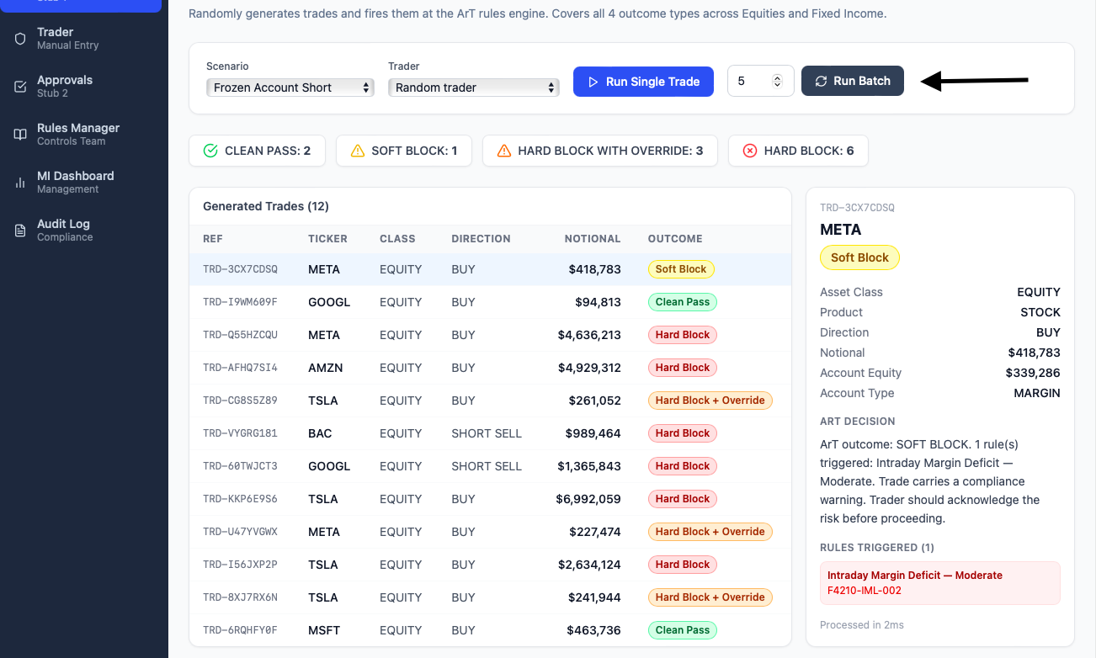
Figure 5 — Running a batch of trades; the outcome counters and trade list update for all generated trades.

5.2 Supervisory Approvals (Stub 2)
The Approvals view lists all override requests for trades that returned a Hard Block with Override outcome. Supervisors review each request — including an AI-generated risk score and rationale — and approve, reject, or escalate it.
How to get here: Left-hand navigation menu → “Approvals” (marked “Stub 2”).
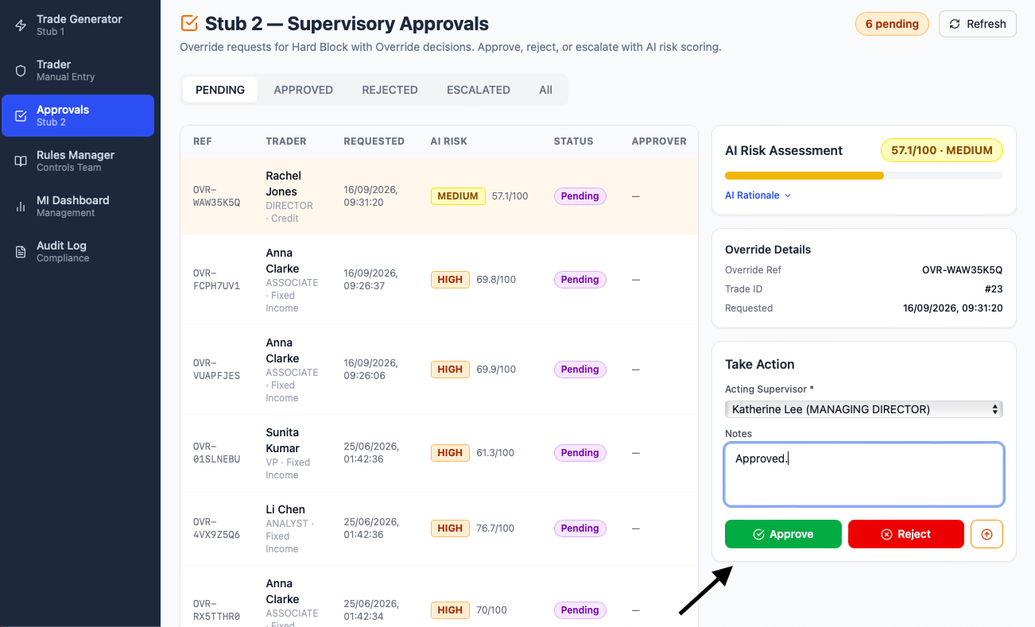
Figure 6 — Pending override requests with AI risk assessment; select a request, choose the acting supervisor, add notes, then Approve or Reject.
Use the tabs above the list (Pending, Approved, Rejected, Escalated, All) to filter by status.

5.3 Rules Manager (Controls Team)
The Rules Manager lists every active pre-trade control rule — Regulation T, FINRA 4210, and custom in-house rules — with its code, type, scope, block level, and priority. New rules can be added in plain English using the AI Natural Language Rules Builder at the top of the page.
How to get here: Left-hand navigation menu → “Rules Manager” (marked “Controls Team”).
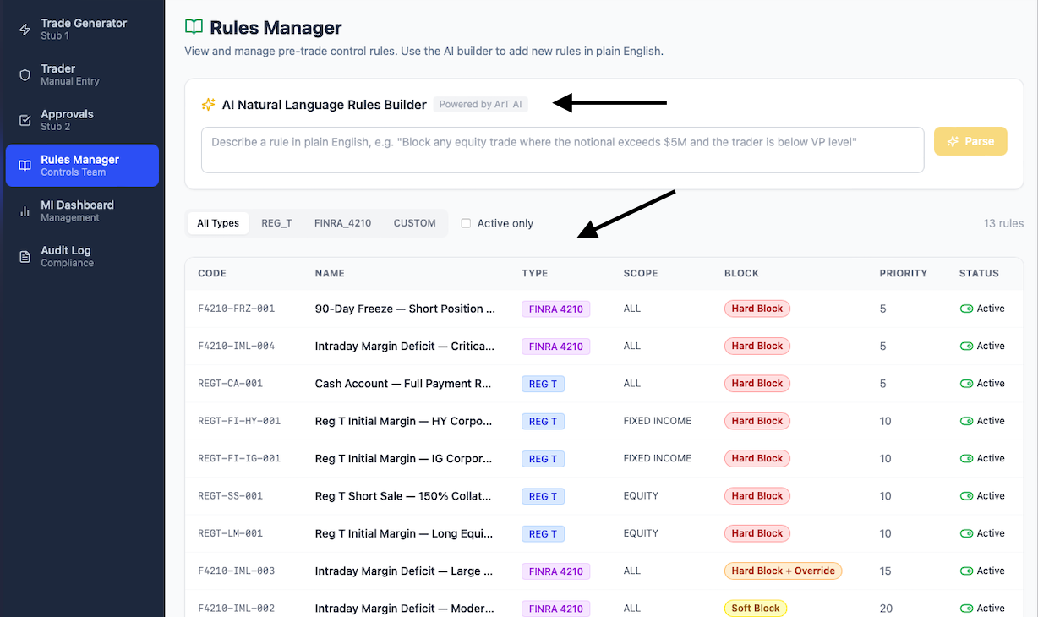
Figure 7 — The AI Natural Language Rules Builder (top) and the full rules table, filterable by type (Reg T, FINRA 4210, Custom).

5.4 MI Dashboard (Management)
The MI Dashboard gives management a real-time view of platform activity: total trades, outcome counts, a 14-day decision trend, outcome distribution, the top rules triggered, and the traders with the most block decisions. Use the date-range selector at the top right to change the reporting window.
How to get here: Left-hand navigation menu → “MI Dashboard” (marked “Management”).
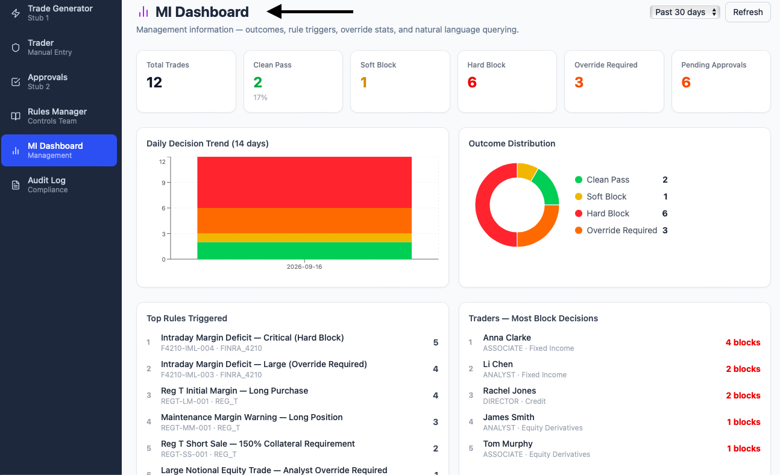
Figure 8 — MI Dashboard summary tiles, decision trend, outcome distribution, and top rules/traders tables.

5.5 Audit Log (Compliance)
The Audit Log is an immutable record of every ArT decision, override action, and system event, with timestamp, event type, related trade, acting user, and a description. Use the date-range and event-type filters at the top to narrow the log.
How to get here: Left-hand navigation menu → “Audit Log” (marked “Compliance”).
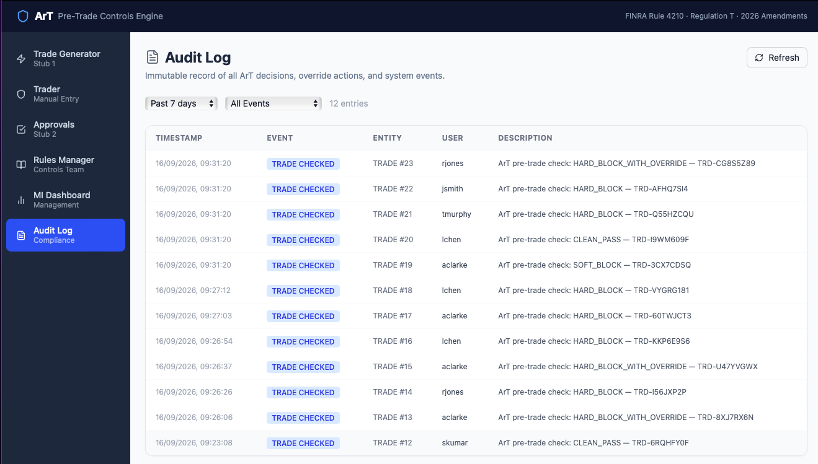
Figure 9 — Audit Log showing every trade check event, filterable by date range and event type.

